Analysis stage

Introduction

as part of a company’s overall profit, it is vital that the cost of delivering its stock is reduced as low as possible. The advantages of this is mainly that the overall profit can be reduced as little as possible, and makes a companies’ reputation towards the environment look clean. So a way to do this is to treat it as a transportation problem. The transportation problem is used to find an optimal solution of the minimum cost of delivering multiple stock, while the multiple warehouses that demand the stock get the full amount they need.

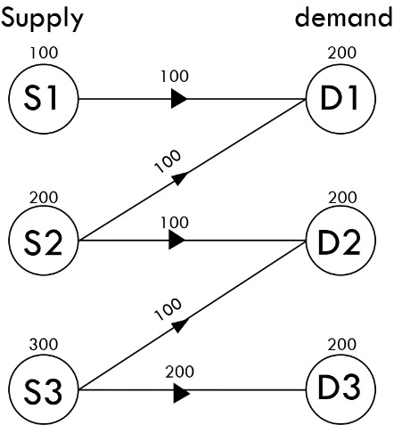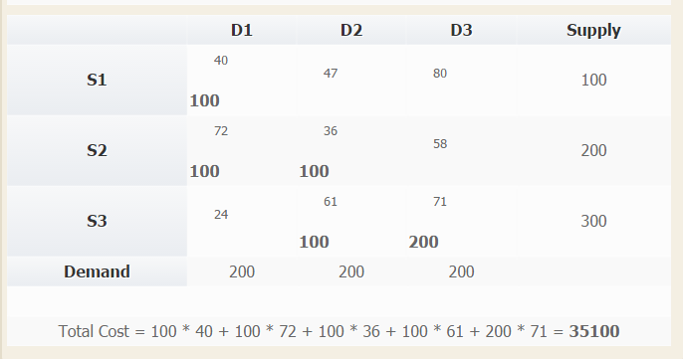The transportation problem is also used in a classroom, teaching decision mathematics. In the end, finding the optimal solution of the transportation problem is crucial and save hundreds or thousands of pounds on delivering goods everywhere for companies.

the pictures above show the initial solution done by the north-west corner method in grid and visual form.

There are multiple ways on how the transportation can be solved, but they all lead to one final optimal solution. in the classroom, the north-west corner method is used at first, followed by shadow costs, stepping-stone method and total cost. This is repeated until an optimal solution is found.

Research

one website that was looked at had a system of solving the transportation problem using the north-west corner method1. It creates an initial solution from the delivery cost cells and the supply/demand amount. This is useful if the student wants to know where to start when using the north-west corner method.

Advantages:

* Able to calculate and show the initial solution
* Able to customise how many rows and columns are needed to solve the problem.
* Able to give an initial solution of unbalanced problems

1<https://www.easycalculation.com/operations-research/minimum-transportation-northwest-corner-method.php>

Disadvantages:

* Does not clearly state that a dummy column or row was added.
* This system can only be used when online. This means that if the website or the internet connection is down, then the user cannot use it.
* It is not very clear on which numbers is which, and making it confusing.
* It does not give you the optimal solution. even if this calculator only does the north-west corner method, it is a useless system for companies to use.

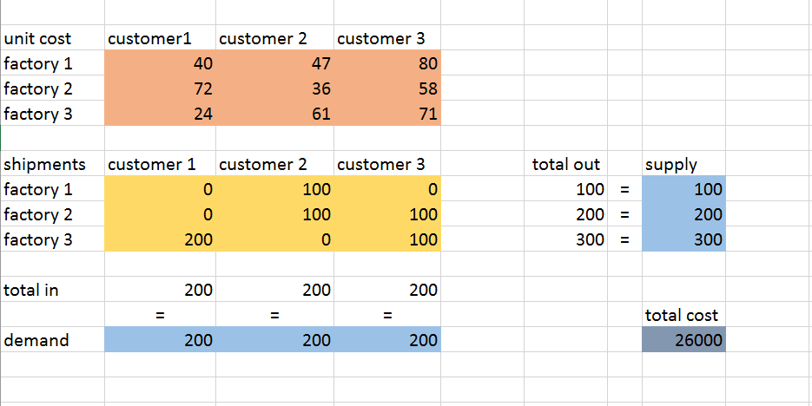Another way to solve the transportation problem is inside Excel and using a spreadsheet. I also used the website help create a template and follow instructions, finding the optimal solution. The main path is to enter numbers into the correct places, find an initial solution, use the solver in excel and entering the values that are being used, and you will be given an optimal solution.

Advantages:

* With this, you are able to use the method offline, if you know what you are doing.
* The grids are can be done clearly and organised, which is useful and can be placed anywhere as long as it is selected in the solver

Disadvantages:

* It is a fairly difficult procedure to do as, sometimes, it requires the user to get the solver add-in in later Excel programs, and even worse, requires you to search through the disk drive to find the add-in.
* It’s a process that takes a long time to create because not only you have to enter all of the data, but also the total in and out which is not necessary if done correctly.
* It cannot solve unbalanced problems. This means that a dummy column/row has to be manually placed in, whereas the website version1 creates it automatically.
* If you used a 3x3 table and decided to use a 3x4 table, then the formulas for total in and out need to be edited, and the parameters area in the solver need to also be changed as well.

Overall, there is a conclusion about both products:

The website version is simple to use and shows the initial solution of using the north-west corner method. But it does not do anything else. It does not show the optimal solution of the problem by using different methods. Therefore, this system will be useful for students when starting the transportation problem, but not later on when finding the optimal solution and not useful for companies.

2 <http://www.excel-easy.com/examples/transportation-problem.html>

The Excel version is very structured and clear, and can be used offline. It can be customised and be placed anywhere the user wants it to be. It is also clear on where which stock will go to customers. But it requires complicated installations to access the tool and learn the tool to do what you want.

From these conclusions, the system that I will create for the project need to be:

* Useable even when there is no internet connection
* Allows the user to enter the necessary values it needs to find the optimal solution.
* Showa the iterations of the problem being solved, making it useful for students to track their version of the answer, if using the north-west corner method and stepping stone method.
* Does not make the user install anything except for the language the program will be running.

Third party

The end user that this will be look at is Mr. Murphy, a mathematics teacher that teaches decision mathematics at collage.

Objectives

These objectives are the main points of the program:

1. Create a graphical user interface(GUI) that lets the user be able to do what they want to do.
   1. The interface will include spaces for the user to enter their amount of rows and columns and a create button
   2. The create button will create a grid where the user can then enter the numbers.
2. Create a grid-like window that allows the user to enter the delivery cost of each cell and use the options if the user wants to see iterations of the problem or not.
   1. The options will affect the excel file if the user wants to export the solution, as it might include iterations for use of the student.
   2. The grid will be made of small writable blocks that are arranged in a grid. This also means that as the rows and columns will always be different, a certain number of these will be created depending on the user.
   3. The total supply and total demand will be checked to see if the problem can be done. If the demand is more than the supply, then it will give a warning about it. If the user proceeds anyway, they will get an optimal solution but with missing stock.
3. Create various methods that allows the transportation problem to be solved to its optimal solution.
   1. North-west method: create some sort of pointer to know which is being affected at the time and what is not.
   2. Calculating the shadow costs: create arrays that will hold the shadow costs so they can be used later, again some sort of pointer will point which non-empty cell is being used and grab their delivery cost.
   3. Checking if the solution is optimal: by using the shadow costs and the delivery costs with the empty cells, it will find the improvement indices and will determine if the solution is optimal
   4. Finding the entering cell: this will be the lowest of the improvement indices
   5. Using the stepping-stone method: by using arrays, the arrays will include if the row/column has an increasing and decreasing cell, which will update each time a suggestion has been made
   6. Repeat the algorithms, this can be done by using a while loop and if the solution is optimal, will break the loop, carrying the results to the next section.
4. Shows the optimal solution both visually, and written and allows the user to export the excel file if needed.
   1. This can be done by using the grid structure and replacing the writable boxes with labels. This will have the final cost.
   2. For the solution to be written, it will need to have a template sentence to put in the supplier, destination and how much is being transported. This will also have the final cost.
   3. The window will include buttons if the user wants to export the solutions and/not into an excel file.
5. Allow the user to use the program again, resetting everything to default.

These are the optimal parts of the program:

1. Allow the user to get a random transportation question.
   1. Add a “random” button into the main menu that allows the user to create a transportation question using the rows and columns stated by the user.
      1. The rows and columns will create a grid, making it easier to program ahead and less likely for the user to make a mistake if copying a question from a source.
   2. Be able to create a visual grid showing the placement of delivery cost of each cell, and the total supply in and out.
      1. In the window will be the grid, a button for the solution, a button to randomise again and an option if the iterations should be in the excel file if needed.
      2. To reduce the chance of getting a badly constructed question, the program will check if the total supply is equal or more than the total demand. If not, make the program randomly chose more numbers to replace.
      3. What could be done is to add difficulty options that let the user decide if the problem is unbalanced or not.
   3. by pressing the “solution” button, the program will solve its own problem, giving the optimal solution and request if the user wants to export the solution and its iterations.

acceptable limitations:

* the size of the grid will be between the smallest size: 2x2 to the biggest size: 10x10. The reason why for this is that if the size of the grid is too large, the grid might bug out in the size of the window. the reason why the grid size can be at least 2x2 is because a 1x1 and a 1x2 are unnecessary.